**This is the title of your paper**

(Leave a blank line here)

John Monre1, Vijay Kumar2, Akash Kumar Chowdhary3 (All authors name should be separated by “,”)

(Leave a blank line here)

1Affiliation/Organization, 2 Affiliation/Organization, 3 Affiliation/Organization

(Leave a blank line here)

**\***Email ID of the corresponding author: techcom.spg@gmail.com ***(do not add or delete any spaces here)***

(Leave a blank line here)

Keywords

Enter few keywords that are relevant to your paper (at least 3).

Summary

Please explain your work in brief in the summary. **The summary should not be more than 250 words**. **The expanded abstract must strictly adhere with the prescribed format (i.e., this file). This is a mandatory guideline, since SPG is committed to maintain consistency in the formatting of the published proceedings.** Any changes in the format will affect automatic fetching of the contents by the website. Technical Committee SPG will not edit any article. So, it is requested not to change any of the main and mandatory titles “**Keywords”, “Summary”, “Introduction”, “Conclusions”** and **“Acknowledgements**”. You can add additional headings as per your article like, **“Methodology”, “Results”, “Discussions”**, etc. Just replace the text in this template.

Introduction

This is the first paragraph of the Introduction. The expanded abstract is formatted in two columns. **The font for this template is Times New Roman. The Section Headings are 11-point bold Times New Roman and the text of the paper is normal 11-point Times New Roman**.

The Expanded Abstracts will ordinarily be published in the "Proceedings of the Conference" exactly as they are submitted. The maximum length of the expanded abstract should not exceed 8 pages inclusive of all illustrations.

Theory/Method

This is the first sentence of a sample section. All paragraph text should be set for full justification. Note that paragraphs are not indented and are separated by one line of space.

Additional instructions for composition are:

Abstracts must be written in English.

1. Authors are responsible for sizing and positioning their illustrations.
2. Figures can be in black and white or color.
3. **Figures, charts, graphics, etc. must not be submitted separately.**
4. Please remove these bulleted items as they are used as an example only.

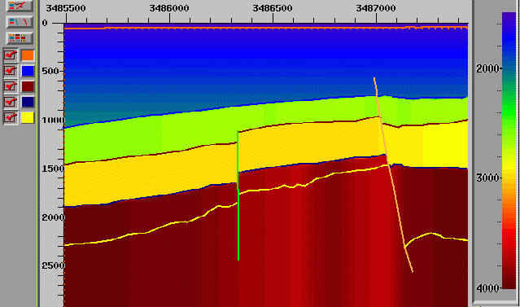

Figure 1: This caption is placed outside the frame. The caption is written in 10 point normal weight Times New Roman font.

**Examples (Optional)**

This optional section describes the examples, case studies, etc (if any).

|  |  |  |  |  |  |
| --- | --- | --- | --- | --- | --- |
| Horizon | Depth | Int. Vel. | G | δ | ε |
| Water Bottom | 58 | 1,480 | 0 | 0 | 0 |
| Horizon A | 774 | 1,580 | .5 | .06 | .135 |
| Horizon B | 1021 | 2,670 | 0 | 0 | 0 |
| Horizon C | 1461 | 2,840 | 0 | 0 | 0 |
| Horizon D | 1597 | 3,810 | 0 | 0 | 0 |

Table1: Tables should be properly annotated with each column head giving units of measurement.

Blank spaces may be inserted for figures, flowcharts and tables above and below, as shown here in the Expanded Abstract.

CMP Gather

PSTM

Velo Analysis

(Small offsets)

Vnmo Shale

4th Order

Velo Anal.

Vo Shale

(Chk. Shot)

Eff. η

Compute ε

Compute δ

Depth Vel. Modelling

With Gradient fr. Sonic

APSDM

Figure 2: Description of flowchart here.

Pages 2-8 (last page) will need to have a shortened version of your paper title in the header (running title). The header is set up to begin on page 2 and appear on all succeeding pages.

Double click on the header, replace the existing text with the shortened version title for your Expanded Abstract, and click the close button.

Kindly note that large sized figures viz. seismic sections, a maximum of two column wide, are also acceptable. The frame can be duly expanded in such a way that it does not hide the text in adjacent column.

**Conclusions**

This is a mandatory section. Please enter here all the conclusions of your study.

**There should not be any reference of the author(s), affiliations, author(s)’s photo, bio-data, or any other detail that can possibly reveal the identity of the author anywhere in the text other than at the defined positions (top of the paper and acknowledgements).**

References

All references appearing in abstract must be mentioned here in the format shown below.

Al-khalifah, T. and Tsvankin, I., 1995, Velocity analysis for transversely isotropic media; Geophysics, 60, 150-1556.

Backus, G. E., 1962, Long-wave elastic anisotropy produced by horizontal layering; J. Geophysical Res., 67, 4427-4440.

Thomson, L., 1986, Weak elastic anisotropy; Geophysics, 51, 1954-1966.

Acknowledgements

Acknowledgements should be placed at the very end as shown in the template. You are advised to acknowledge your employer / colleagues for their permission / help rendered during the course of this work.

Expanded abstracts should only be submitted online (by the SPG link) provided at SPG website.

Finally, the actual figures, tables and flowcharts etc. have to be positioned where you want them to appear within abstract so as to not to make the file too heavy for e-mailing. File sizes up to 15 MB are supported.